Farmers ZSOA
Zurich Services Oriented Architecture

FNOL - Mappoint Service
Technical Design

Version 1.0



Farmers Service Competency Center

Copyright Zurich Financial Services

Document History

Version | Date | Author | Comment
1.0 | 06/10/2008 | Emmanuel Ameh | Initial Draft

Table of Contents
1 About this Document 5
1.1 Introduction 5
1.2 Intended Audience 5
1.3 How this document is organized 5
1.4 Reference Architecture 5
1.5 Service Overview 8
2 Orchestration Layer Components 10
2.1 ESB Components 10
2.1.1 ALSB 10
2.2 Client interface 11
2.3 Message flow 11
2.4 Transformations 12
2.5 Routing 13
3 Service Enablement Layer Components 14
3.1 Interface 14
3.1.1 Functionality Required 14
3.1.2 Inputs 14
3.1.3 Outputs 14
3.1.4 Faults 15
3.1.5 Data Modifications 15
3.1.6 Logical Flowchart 15
4 Implementation Layer Components 16
4.1 Class Diagram 16
4.2 Mainframe Programs 17
4.2.1 Program Name 17
4.2.2 Region 17
4.2.3 Linkage section 17
4.2.4 Procedure Division declaration 17
4.3 EJB’s 17
4.4 Database\Stored Procedures 17
5 Functional\Non-functional requirements 18
5.1 Functional 18
5.1.1 Feature specifications 18
5.2 Non-functional 18
5.2.1 Security 18
5.2.2 Logging 18
5.2.3 Monitoring 18
5.2.4 Business exception handling 18
5.2.5 Response time 18
5.2.6 Concurrent Users 18
5.2.7 Availability 18
6 Business Contacts 19

About this Document

Introduction
This document describes the design artifacts and implementation model of the Mappoint Service. Although external systems (upstream and downstream) are referenced in this document, their detailed behavior falls outside the scope of this document. Overall system requirements are covered in the requirements and use case document and, therefore, also fall outside the scope of this document.

Intended Audience
This document is intended for the team members who will be responsible for development of this service.

How this document is organized
The design for the Mappoint Service is presented in 4 areas of interest as outlined below.
- Orchestration Layer Components: Presents the services, components and information pertinent to this level. The primary focus here is on the Enterprise Service Bus and the activities carried out there.
- Service Enablement Layer Components: Describes the design and pertinent aspects needed to develop the atomic services as well as any other aspects implemented at this level.
- Implementation Layer Components: This deals primarily with backend or legacy data sources and the design to follow in exposing their services to the enterprise.
- Functional\Non-functional Requirements: This section outlines the functional and non-functional requirements identified for this service.

Reference Architecture
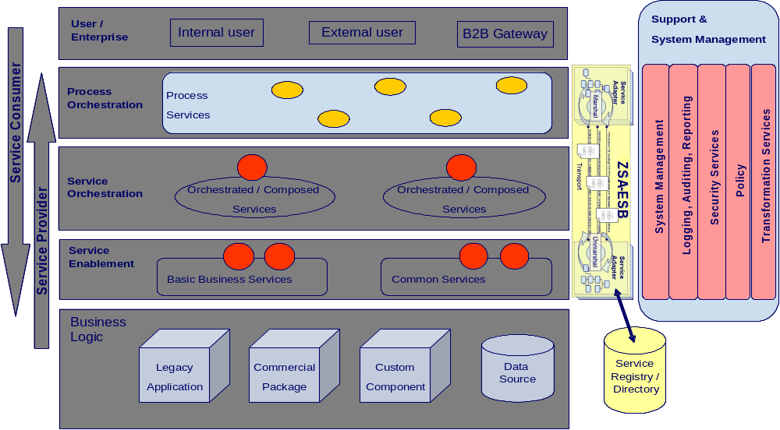

Fig 1.1
As shown in the above diagram, the Mappoint Service will follow the reference architecture defined in the “ZSA_Tech_Ref_Architecture” document.
The special implementation is required for security and transformation for providing web services to the (Consumer). The detail of the implementation is explained below:
The end-to-end flow for the provider MAPPOINT will follow the steps shown in the diagram 1.2:

PEGA
(FNOL - AUTO)

O R
LOAD BALANCER
retrievePartyContactPointDetails( )
getRoute( )
getLocationMap( )
Data Power
(Data Transformation)
MAPPOINT
(EXTERNAL PROVIDER)

IAA Request

O R

Diagram 1.2

As shown in diagram 1.2, PEGA / FNOL - Auto consumer sends the zip code as string and gets a response which contains: Vendor Id, Vendor Name, Address, City, State, Zip, Phone, Fax, Customer Representative as well as the Map and directions to the location.
Based on the zip code the ALSB proxy service will do the content base routing. We have specific hard coded constant values for the vendors.
Here Mappoint Service component returns Vendor location and contact information (includes address and organization) as well as the map and directions to the location in the response messages.

Service Overview
This service will return the Vendor information and location depending on the zip code provided by the service consumer.
The following diagram gives a high level overview of the service’s structure. As per the reference architecture, Party Object has implementation components in the Service Enablement, Atomic, and Orchestrated layers.

PEGA
(FNOL - AUTO)

.

PARTY

IPostalAddressManager:
getRoute( )
getLocationMap( )
IProviderInformationManagement: retrieveProviderContactPointDetails( )

SOAP / HTTP
MAPPOINT
(EXTERNAL PROVIDER)

Anticipated URLs for Vendor search result INET will provide to Siebel team. Once the results have been displayed, INET will take over all mapping functionalities such as zooming and panning:

Development: http://testdev.farmersinsurance.com/FarmersLocationSearch/SearchResults.aspx
QA: http://qa.farmersinsurance.com/FarmersLocationSearch/SearchResults.aspx
Maintenance: http://maint.farmersinsurance.com/FarmersLocationSearch/SearchResults.aspx
Production: http://crn.farmersinsurance.com/FarmersLocationSearch/SearchResults.aspx

4. Two web pages will be developed by INET that will display Map Location and Driving Directions. These pages will be available to Siebel indirectly and the main Farmers Insurance Group site directly for integrating their Agent Search application.

Orchestration Layer Components

ESB Components

ALSB

2.1.1.1 Business Service
This section contains the detail necessary to define the business service in the ESB.

General Configuration
Service Name | - PostalAddressManager B) ProviderInformationManagement
Description | - The purpose of PostalAddressManager service is to retrieve the vendor location map as well as the step-by-step directions to the location.  - The purpose of ProviderInformationManagement is to retrieve the list of vendors and the selected vendor’s location information, for a given zip code, from external provider Mappoint.
Service Type | Web service
Transport Configuration
Protocol | HTTP
Load balancing | Yes
Endpoint URI | http://services.farmersinsurance.com/services/<<tbd>>
Retry count | 0
Retry interval | 0 seconds
HTTP Transport Configuration
Timeout | Default to server
HTTP Request Method | Post
Authentication | No
Follow HTTP redirects | Yes
SOAP Binding Configuration
Enforce WS-I Compliance | Yes

2.1.1.2 Proxy Service
This section contains the detail necessary to define the proxy service in the ESB.

General Configuration
Service Name | - PostalAddressManagerProxyService  - ProviderInformationManagementProxyService
Description | This services fronts the primary business service
Service Type | WSDL Web Service
Proxy Service Provider
Protocol | HTTP
Endpoint URI | http://services.farmersinsurance.com/services/<<tbd>>_proxyService
Get All Headers | Yes
Headers
HTTP Transport Configuration
Authentication | No
Message Level Security Configuration
Custom Authentication | No
Operation Selection Configuration
Enforce WS-I Compliance | Yes
Selection Algorithm | SOAP Body Type

2.1.1.3 WSDL
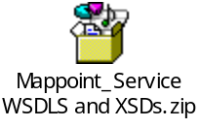

Client interface
A consumer will access this service via a WS-I v1.0-compliant web service invocation. This service uses the wrapped document literal binding style. The request/response messages are in IAA canonical format and the consumer has the responsibility to map the XML message structure to their internal format.

Message flow
Message Flows are the definitions of AquaLogic Service Bus proxy services. Pipelines (Request and Response pipelines), branch nodes, and route nodes define the implementation of AquaLogic Service Bus proxy services. There will be a Pipeline Pair required to handle the request and response, and Route node required and there is no requirement for branch nodes. ALSB which provides a route node is used to perform request/response communication with Proxy service and Mappoint service. The route node supports conditional routing as well as request and response transformations.

Transformations
Data transformation is the mapping of data from one format to another. DataPower transforms messages from IAA format to the service provider’s format. It uses the Xquery, XSLT transformation and XPath language for data composition and transformation for service endpoints. Data power supports data mapping that uses XQuery and the eXtensible Stylesheet Language Transformation (XSLT) standards. There is only one transformation component at the Data Power for transforming IAA service request (IAA message) to MapPoint service request. There is no data transformation since Mappoint identifies SOAP/HTTP messages.

Routing
There is no need for routing as there is only one provider for the consumer of this service. FNOL is sending request to Mappoint. In order to route the consumer requests to different providers, we follow content based routing.

Service Enablement Layer Components

Interface
The Mappoint Service is to be the result of building a service layer to interact with new third party vendor providers.

Functionality Required
A new service is to be enabled under Party Package in IAA. The WSDL files to be implemented for this service are located in section 2.1.1.3. Service enabling this new calling program will require mapping of the ZIAA canonical model to the existing inputs and outputs. The following table shows the native input\output element to ZIAA WSDL mapping
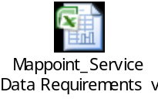

Inputs
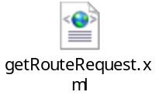
Use Case Parameter | Type | Element | Schema
ZIP Code | String

Outputs
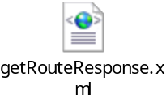

Use Case Parameter | Type | Element | Schema
VendorId | String
VendorName | String
Address | String
City | String
State | String
Zip | String
Phone | String
Phone Fax | String
Last Name | String
First Name | String
Middle Name | String
Email | String
Directions URL | String
Map Image | binary

Faults

U.C. Parameter | Element | Type | Schema
Technical Error | errorMessageType | String | (ZSOA.xsd)
Business Error | errorState | String | (ZSOA.xsd)

Data Modifications
Identify any data modifications which need to occur in the service enablement layer.
Field Name | Modifications
None

Logical Flowchart
Begin
ZIP
Call Mappoint Service to display Vendor search results, directions and location map .
Mappoint processes the request
processes the request
End
Yes
Success/failure

Create Error Message
Failure
Send response through ALSB to FNOL, PEGA
Success

Implementation Layer Components

Class Diagram

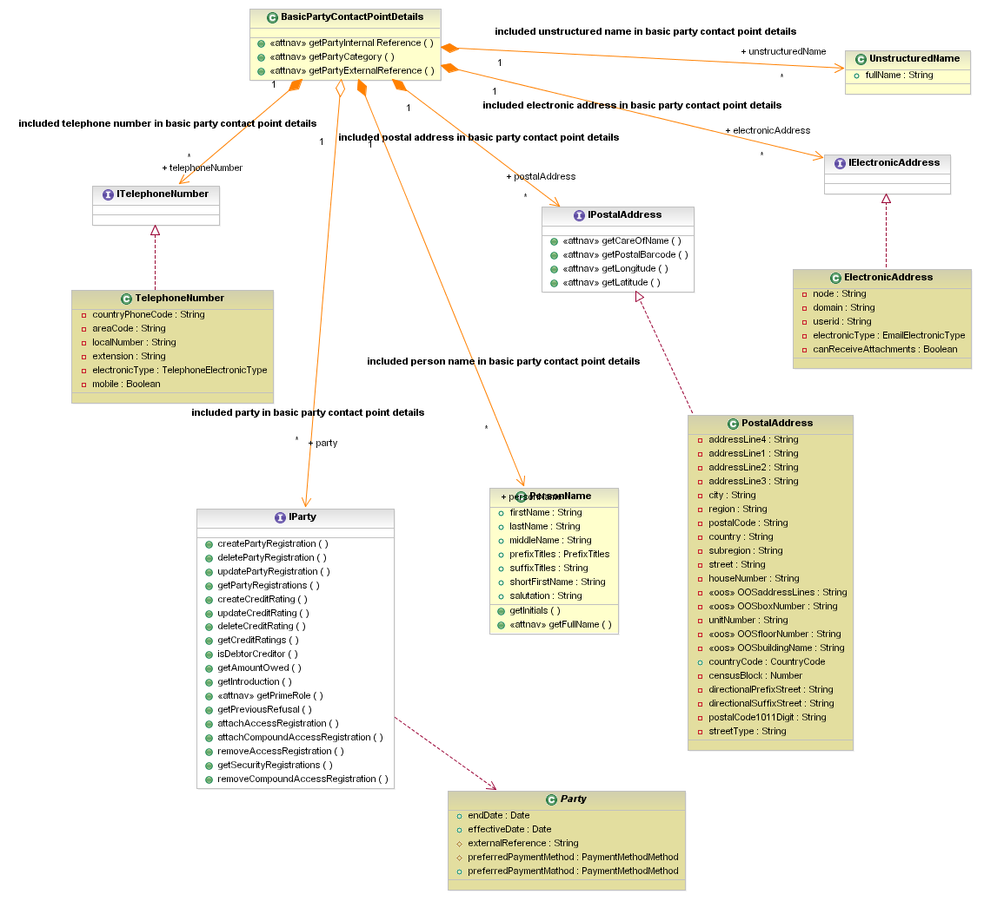

Mainframe Programs
<<None>>

Program Name
<<None>>

Region
<<None>>

Linkage section
<<None>>

Procedure Division declaration
<<None>>

EJB’s
<<None>>

Database\Stored Procedures
<<None>>

Functional\Non-functional requirements

Functional

Feature specifications

Non-functional

Security
Since both the providers are public network, there is no message level and transport level security needed for this service. However, the service should be accessible within Farmer’s domain.

Logging

Monitoring
Monitoring by Amber-point

Business exception handling

Response time
The response time should be within 3sec.

Concurrent Users
PEGA, FNOL - Auto

Throughput Requirements
On an average, for FNOL-WC system sends 300 (service requests)/day to this service. Whereas the throughput expectations from FNOL- Auto Mappoint system is around 30,000 (service requests) / day.

Availability
As far as availability is concerned, the MAPPOINT system is available 100% of the time.

Business Contacts
Name | Company | Role | Email address
Kathy Hartley | Famers,HO | Program Manger | kathy_hartley@farmersinsurance.com
Goutham Nellutla | Farmers | Program Manager, Farmers Services Competency Center | goutham.nellutla@farmersinsurance.com
Mukesh Agrawal | Farmers | Program Manger | Mukesh.agrawal@farmersinsurance.com
Venkata Pushpala | FNOL - WC | Integration Team Lead | Venkata.pushpala@farmersinsurance.com

